Greater Des Moines Softball Hall of Fame

Meeting May 12, 2015

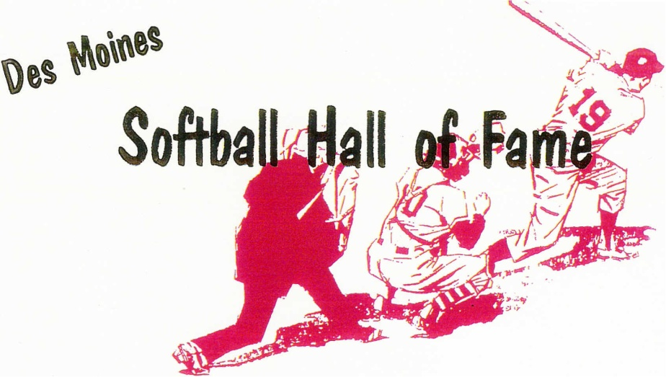
Pres. Mike Clark
VP. Chuck Welker
Sec. Tony Nelson
Treas. Kevin Walker

dmfastpitch@hotmail.com

Meeting held on September 9, 2014 Call to order: 7:00 PM

Meeting attended by 26 members:
Roger Aceto, Gordy Baker, Gary Christensen, Mike Clark, George Davis, Mike Fuller, Robert Mahaffey, Tony Nelson, Al Van Dyke, Kevin Walker, Chuck Welker, Sammy Allgeier, Dick Kimm, Alex Quijano, Henry Quijano, Ray Quijano, Dave Temple, Slim Vanderwaal, Dave Thomason, Tom Stokesberry, Floyd Hazelbaker, Tarry Cory, Gary Alberhaskey, Dennis Pucket, Tony Russo, Randy Ripperger

Minutes for Sept 9, 2014 meeting were approved as read - unanimous

Kevin Walker gave treasurer's report.
- $130 donations from various people and $40 from Dick Kimm.
- Roger Cleven passed away Nov 3, 2014 – A donation of $50.40 for plant was made to his memorial.
- All bills are paid: the current balance is $741.35.
- Treasurer’s report approved as read - unanimous

Old Business :
- Sept 2014 motion to amend the by-laws from Gary Christensen to be voted upon.

Motion from Sept 9, 2014:
A Motion by Gary Christensen was presented to amend the By-Laws for how future resumes will be screened and presented for a vote. The new process will now read “ALL qualified/valid resumes that are presented to the active membership will be read and voted upon during the September meeting”. This would replace the existing process for accepting the resumes and putting them thru a screening process by the executive board. George Davis second. A 2/3 vote is needed by the active membership in two consecutive meetings for the By-Law to be changed. The motion needed 13 votes during the Sep 2014 meeting to pass and the vote was held and had 14 votes in favor of the motion.

This motion was presented again at this May 12th 2015 meeting for a second round of voting. We will need a 2/3 vote from the active membership for the motion to carry and the By-Laws be amended. 26 members in attendance and 18 votes are needed for the motion to pass.

Voting on this motion was conducted and the results were 6 in favor and 20 not in favor.

The Motion to amend the by-laws is denied.

New Business:
Chuck Welker presented the need to do a another fund raiser as our treasury account is being depleted. Our last fundraiser was 4 years ago when we raised money for the display at Hilltop.

As of the end of the meeting we had the following donations to the HOF:
Denny Linderbaum $250, Gary Alberhaskey $300, Fuller $100, Chuck Welker $250, Floyd Hazelbaker, $100, Bob Mahaffey $150, Kevin Walker $100, George Davis $301, Dennis Pucket $50, Dave Thomason $100, Alex Quiano $100, Gordy Baker $150 Al Van Dyke $300.

Any Checks being mailed to the HOF, please make them out to DSM Softball Hall of Fame. Our goal is to raise $4000 by the September meeting.

Send checks to the following:

Chuck Welker
5170 Waterfront Ct
Pleasant Hill, IA 50327
(515-262-2977 Home 515-491-9192 Cell)

Any resumes that are to be considered for this falls induction will need to be turned in by July 1. Send all submissions to
dmfastpitch@hotmail.com

Meeting was adjourned at 7:45PM

